1-What is the truth table of these gates?

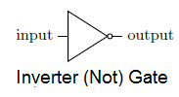 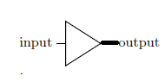

2-This Truth table belongs to which gates?

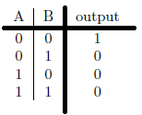 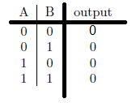 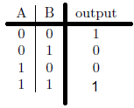

3- Which ones have the same outputs?

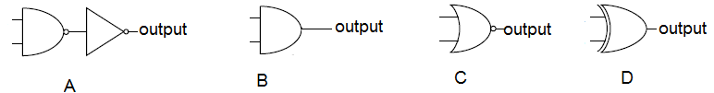

4-The same question for these ones:

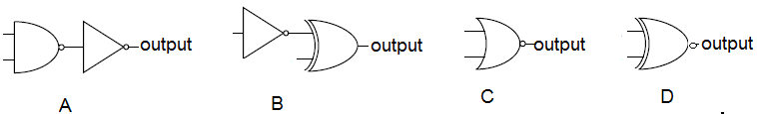

5-Which one is wrong?

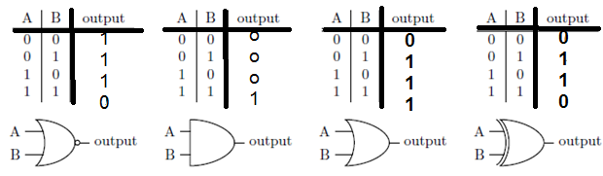

6-Can we realize a NOT gate using NAND gate?

7- How can we make an AND gate Using NAND gate?

8- What about a NOR Gate?

9-Which one is a NOT gate?

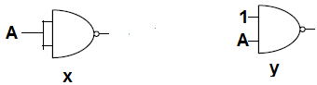

10- Which one is a NOT gate?

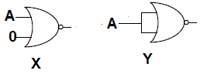

11- What is ab’+a’b ?

12- What is (a’b’+ab)’